How to set up three node clusters in kubernetes.

**Step 1:**

* Create three EC2 Instances in AWS with t2.medium configuration.
* Open Ports As Per Image on Master and Worker Node.

**master-node:**

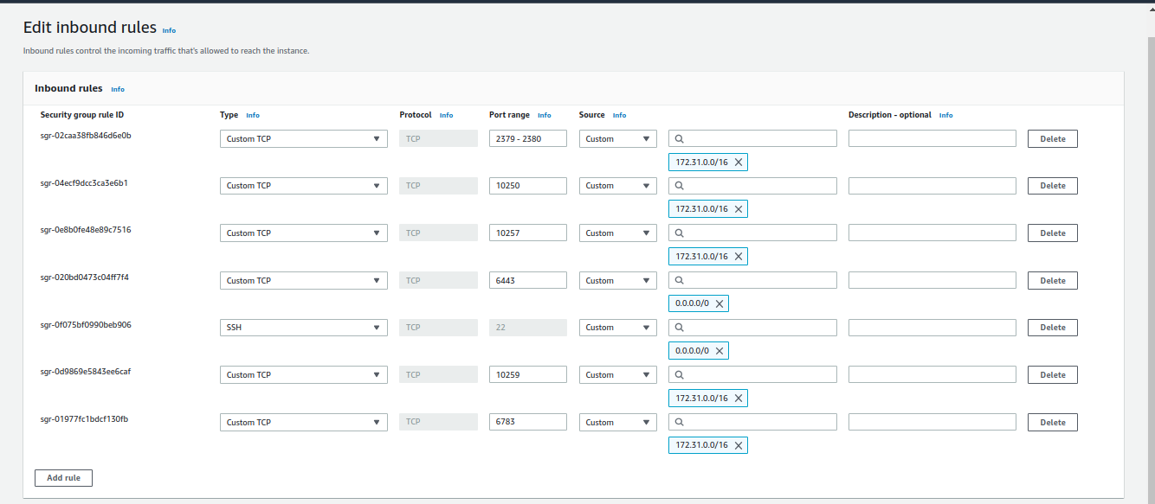

**Worker-nodes:**

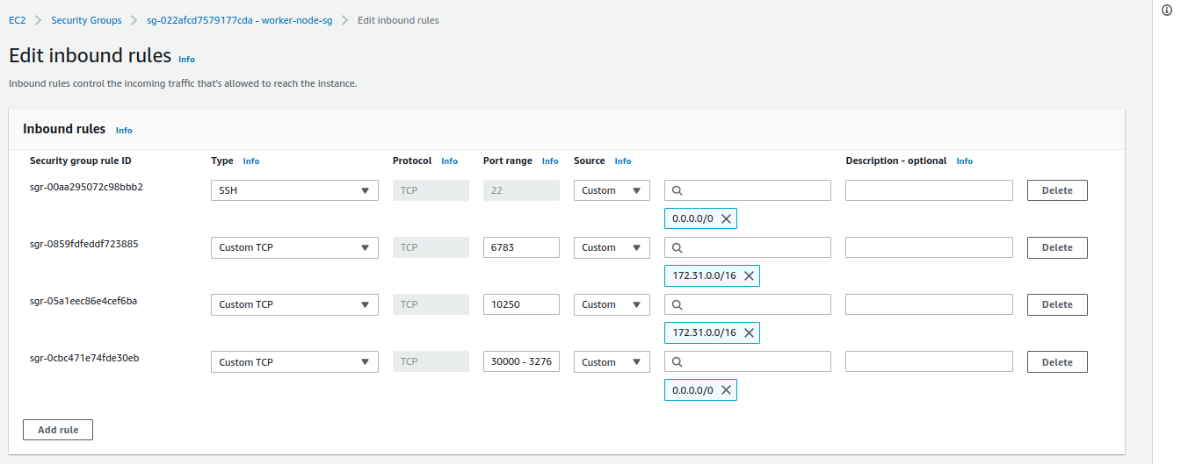

**Reference Link:** [**https://kubernetes.io/docs/reference/networking/ports-and-protocols/**](https://kubernetes.io/docs/reference/networking/ports-and-protocols/)

**Step 2:**

Let's do some tasks at EC2 Machines Level..

**i) Change the hostname of nodes as below:**

master-node: sudo hostnamectl set-hostname master-node

worker-node-1: sudo hostnamectl set-hostname worker-node-1

worker-node-2: sudo hostnamectl set-hostname worker-node-1

**ii) Add the entries in host file as per below on /etc/hosts path with root privilege:**

172.31.22.17 master-node #master-node private ip

172.31.31.66 worker-node-1 #worker-node-1 private ip

172.31.23.83 worker-node-2 #worker-node-2 private ip

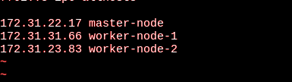

**iii) sudo swapoff -a**

**Step 3:**

Now, It's turn to install container runtime on all nodes, so we are going to install containerd.

**Reference Link:** https://kubernetes.io/docs/setup/production-environment/container-runtimes/#containerd

Install_containerd.sh file location:

<https://github.com/impankaj91/Kubernates-CKA/blob/main/Three-Node-Cluster/install_containerd.sh>

chmod +x install_containerd.sh

execute install_containerd.sh script from folder, it will install and configure all dependencies.

**Step 4:**

Install kubeadm, kubelet, and kubectl [Note: All Three Versions Should be Same].

We are using the 1.21.0-00 version.

To check version execute: apt-cache madison kubeadm.

Install_install_kubeadm_kubelet_kubeadm.sh location:

<https://github.com/impankaj91/Kubernates-CKA/blob/main/Three-Node-Cluster/install_kubeadm_kubelet_kubeadm.sh>

chmod +x install_install_kubeadm_kubelet_kubeadm.sh

execute install_kubeadm_kubelet_kubeadm.sh script from folder, it will install and configure all dependencies.

**Step 5:**

**On master node,**

#Initiate the cluster execute below command:

sudo kubeadm init

#execute kubectl get nodes command as a regular user.

mkdir -p $HOME/.kube

sudo cp -i /etc/kubernetes/admin.conf $HOME/.kube/config

sudo chown $(id -u):$(id -g) $HOME/.kube/config

**Step 6:**

Configure networking using weave-net

**Note:** Please make sure that pod network ip not overlap with node network ip range and

change pod ip range **find IPALLOC_RANGE and replace with value** as you like.

Weave-daemonset-k8s.yaml location:

<https://github.com/impankaj91/Kubernates-CKA/blob/main/Three-Node-Cluster/weave-daemonset-k8s.yaml>

on master node execute below command:

kubectl apply -f weave-daemonset-k8s.yaml

**Step 7:**

Add a worker node to the cluster.

On master node, execute below command to create token:

kubeadm token create --print-join-command

Copy the output and execute on the worker nodes with sudo privilege.

now, execute kubectl get nodes -o wide and you see all master and worker nodes.

**Step 8:**

Testing the cluster with sample application run:

kubectl run test --image=nginx

kubectl run test2 --image=nginx

kubectl get pod -o wide

pods will deploy on worker-nodes.

